NAME ORGANISATION / CITY / REGION
VENUE(S) OPEN FOR THE PUBLIC

CONTACT PERSON NAME and FIRST NAME

CONTACT POSTAL ADDRESS
CONTACT MAIL ADDRESS
DATE OF PARTICIPATION EFD (SEPT. 2019)
WEBSITE FOR MORE INFORMATION ABOUT THIS EVENT
DO YOU WISH AN EFD FLAG TO PUT UP AT YOUR LOCATION DURING EFD? (to who on what address should this be sent?)
DESCRIPTION OF THE HERITAGE SITE (short HISTORY)

What can visitors VISIT - SEE - EXPLORE - EXPERIENCE on EFD?

European Fortress Day (EFD) 2019
Participants form
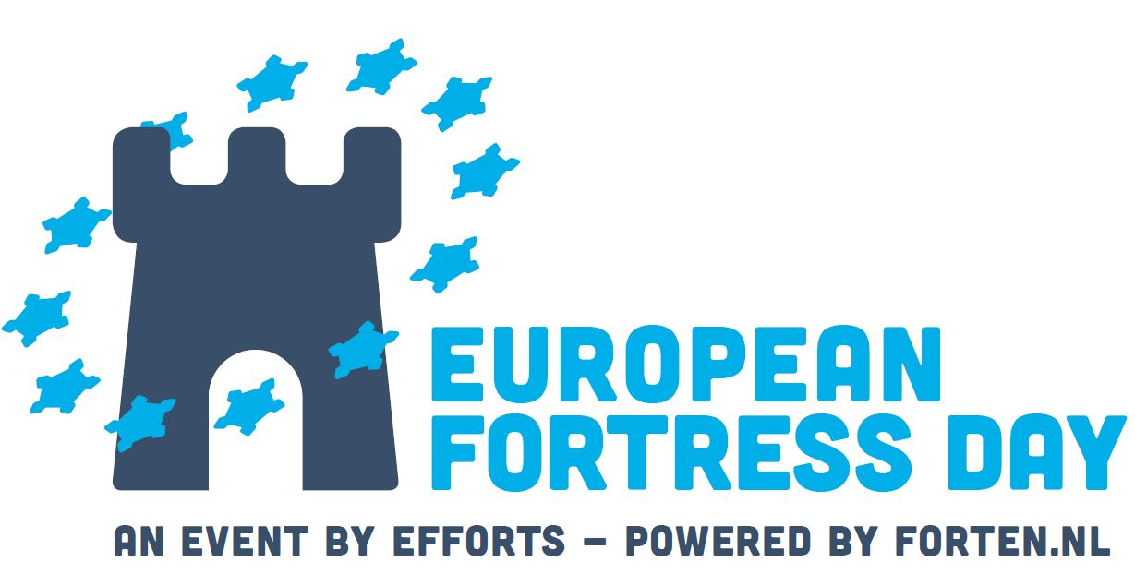

AFTER the EVENT :
Please send us :
- Photos of the event(s), showing public participation and a good view of the venue.
- The number of participants
- Your remarks
- If you are participating in EFD 2020 (April 2020)

Send back this form, all after the event info (pictures in jpg) to titia@liniebreed.nl

European Fortress Day will be organised in APRIL from 2020 on.

By participating in EFD, each participant recognizes it participates in its own name and having ensured all risks at its activities.

EFFORTS AWARD
By participating in EFD, each participant is a candidate for the annual EFFORTS AWARD ! The winners will be presented their award at the 28-29 November 2019 EFFORTS Congress in Antwerpen (BE).
Contact EFFORTS Membership : rafael.deroo@efforts-europe.eu

